**1.Create and Run a Thread using Runnable Interface and Thread class.**

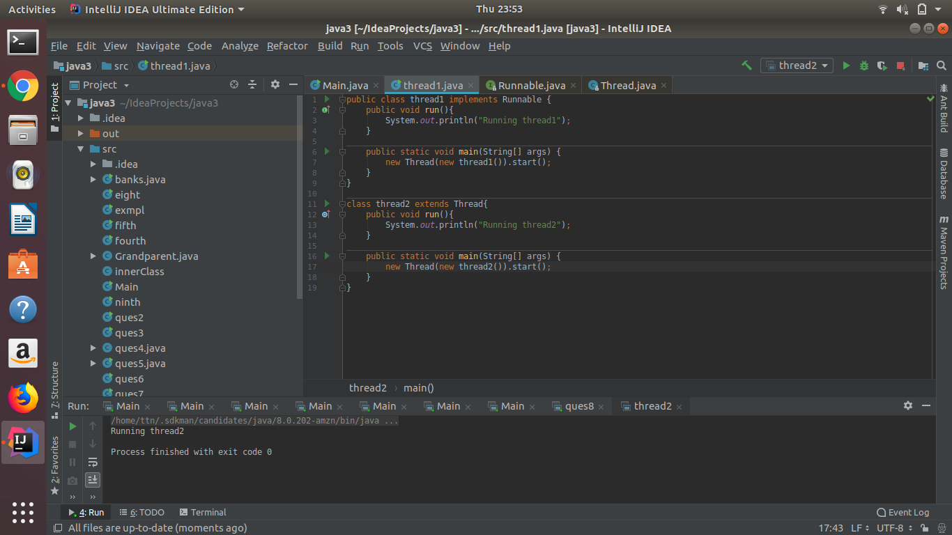

**2.Use sleep and join methods with thread.**

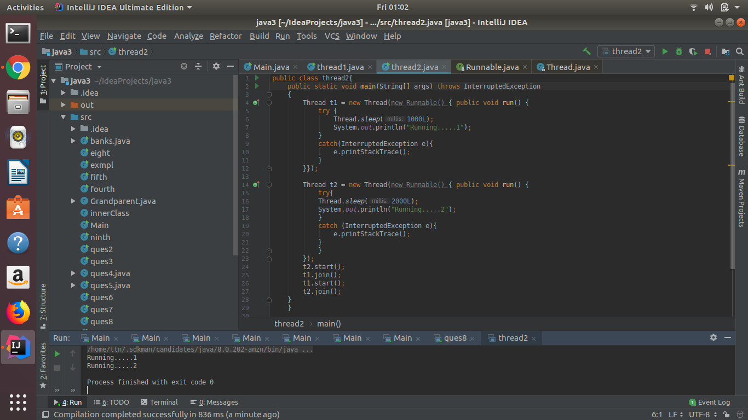

**3.Use a singleThreadExecutor to submit multiple threads.**

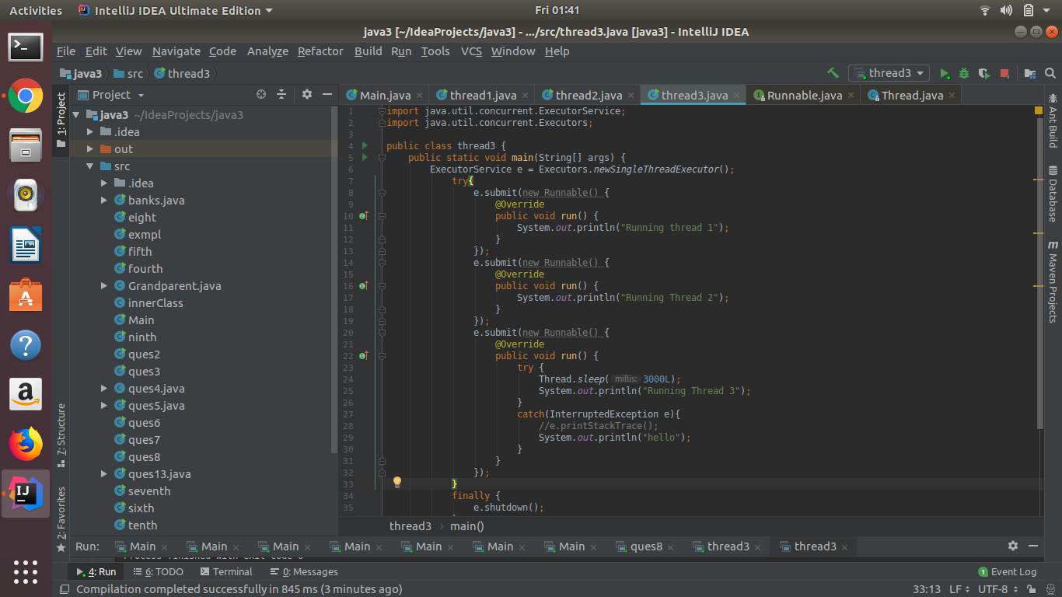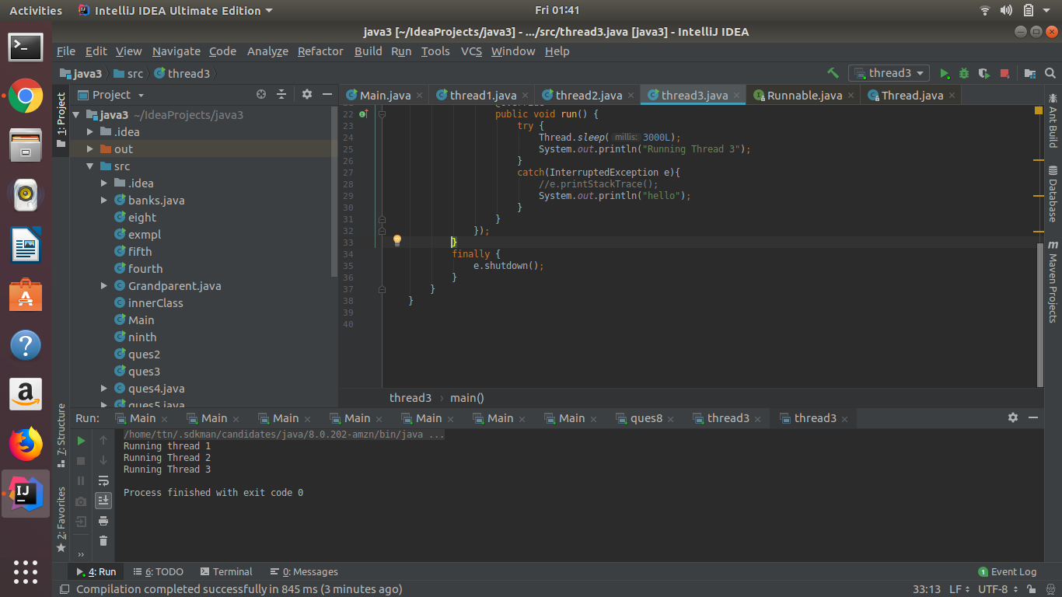

**4.Try shutdown() and shutdownNow() and observe the difference.**

**In above same code if we replace shutdown() by shutdownNow()**

**Then the currently waiting thread i.e. thread3 is been canceled without executed and output is given by e.printStackTrace().**

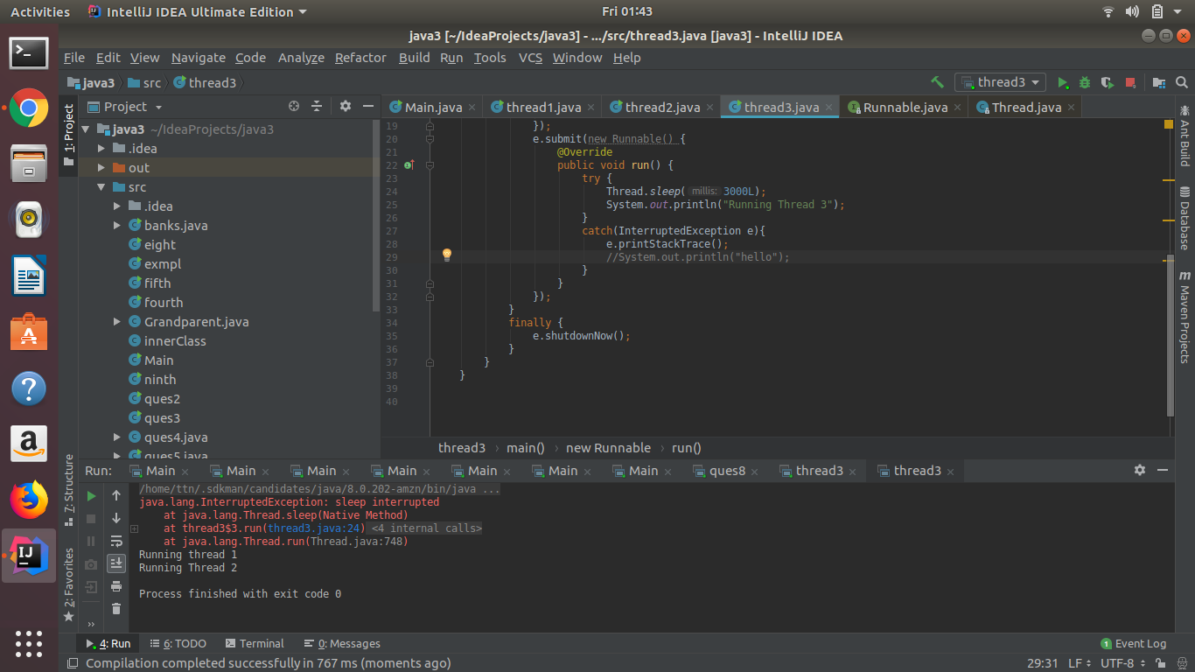

**5.Use isShutDown() and isTerminate() with ExecutorService.**

**If we do shutdown() and then do**

**: isShutDown() -> it gives true**

**: is Terminate() -> it gives true**

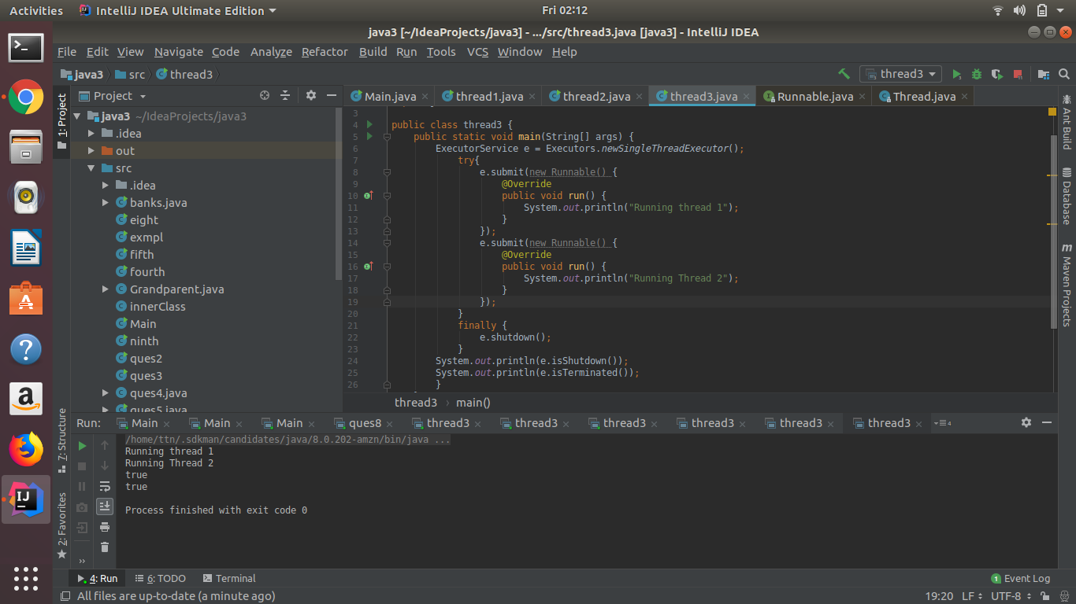

**If we do shutdownNow() and then do**

**: isShutDown() -> it gives true**

**:is Terminate() -> it gives false**

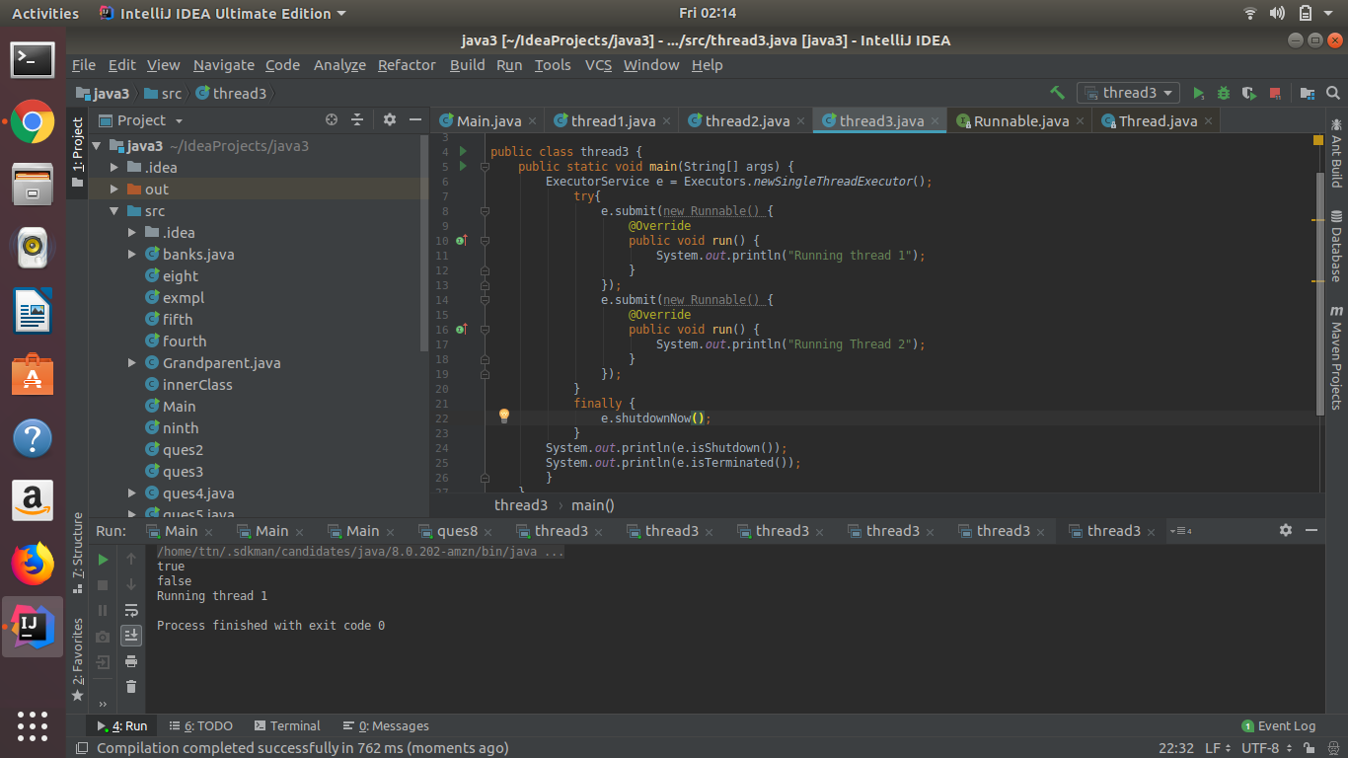

**6.Return a Future from ExecutorService by using callable and use get(), isDone(), isCancelled() with the Future object to know the status of task submitted.**

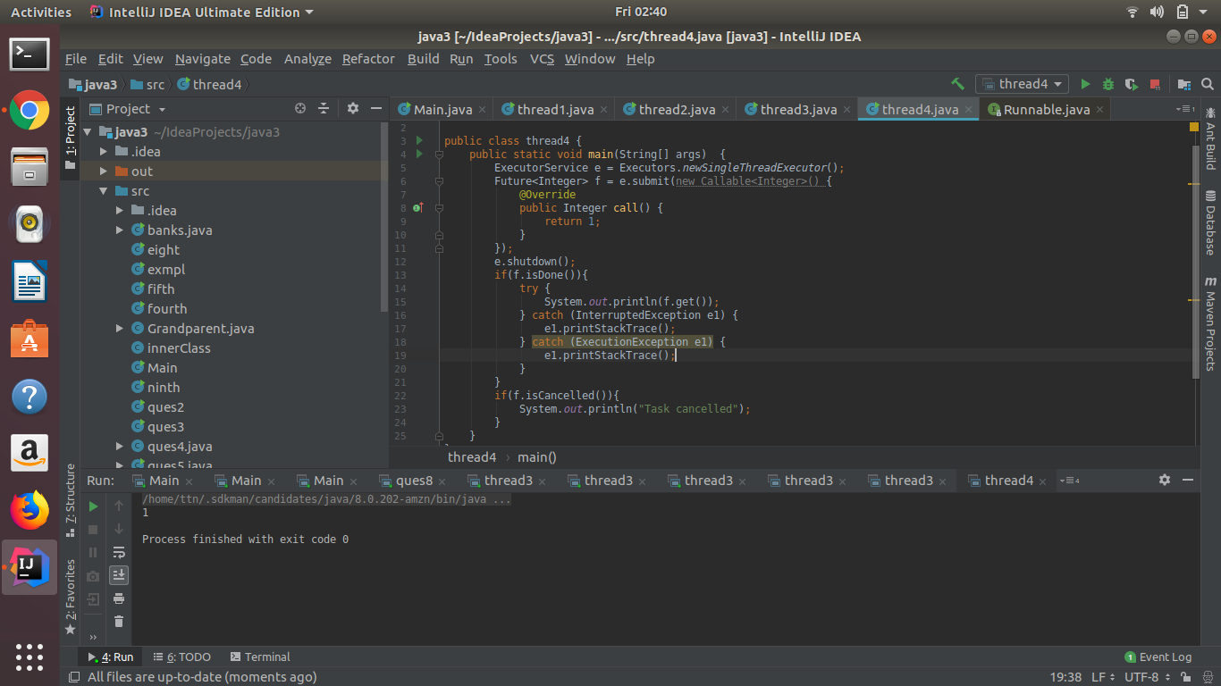

**7.Submit List of tasks to ExecutorService and wait for the completion of all the tasks.**

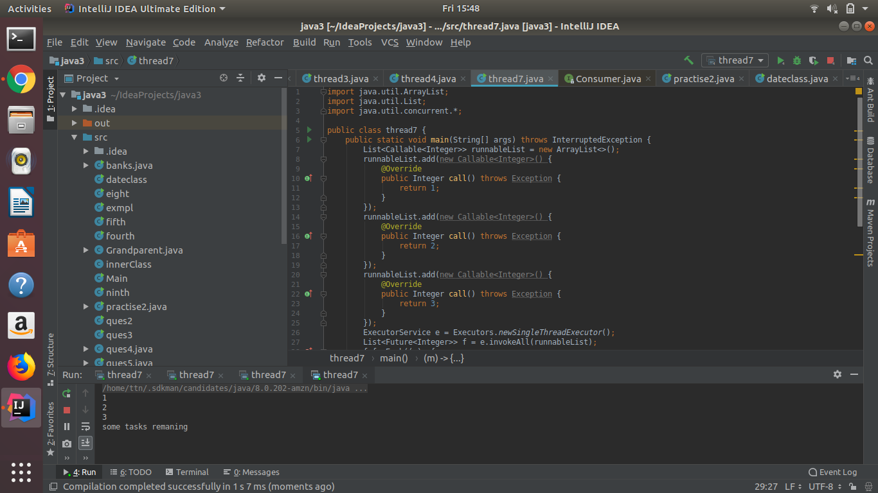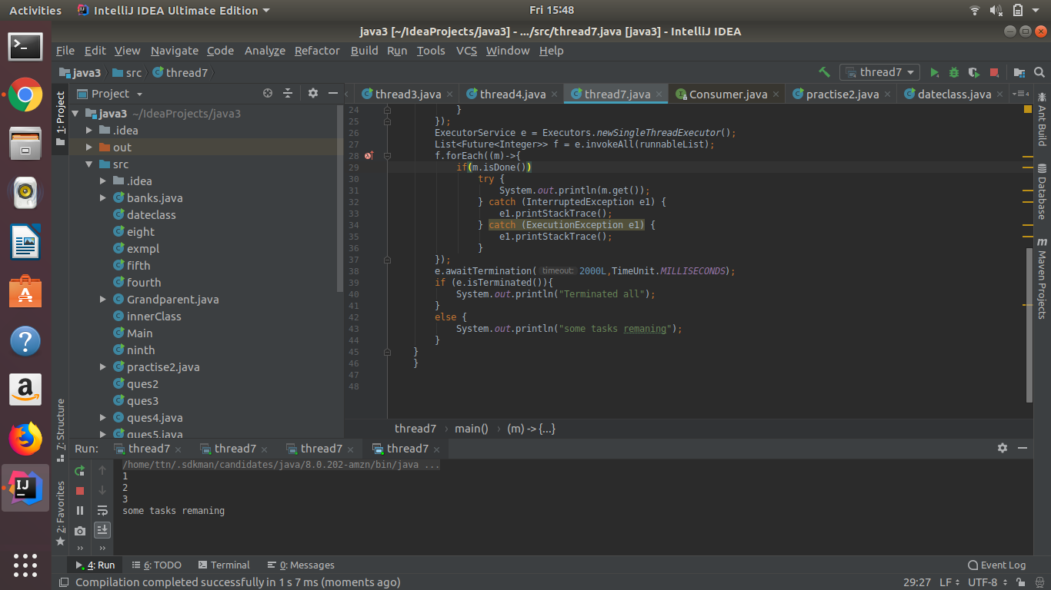

**8.Schedule task using schedule(), scheduleAtFixedRate() and scheduleAtFixedDelay()**

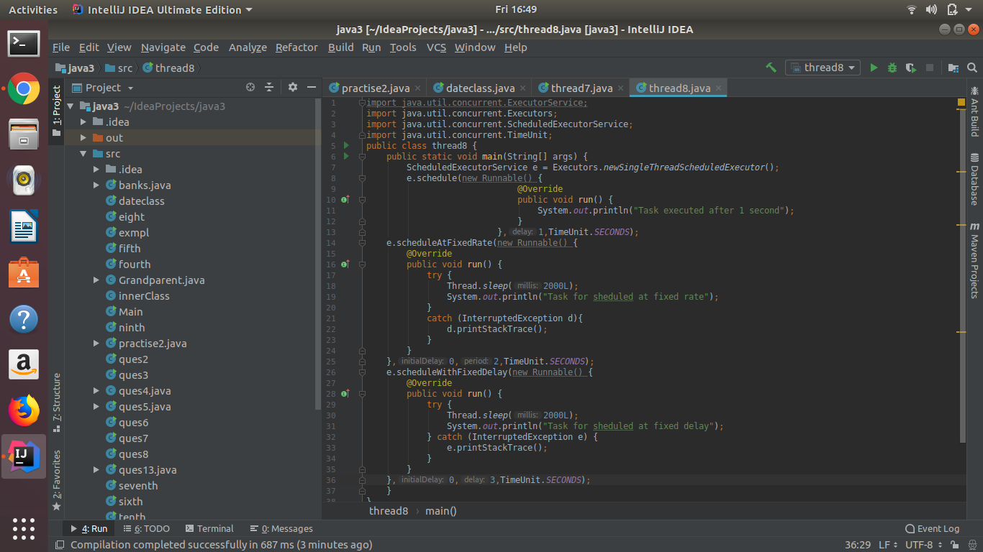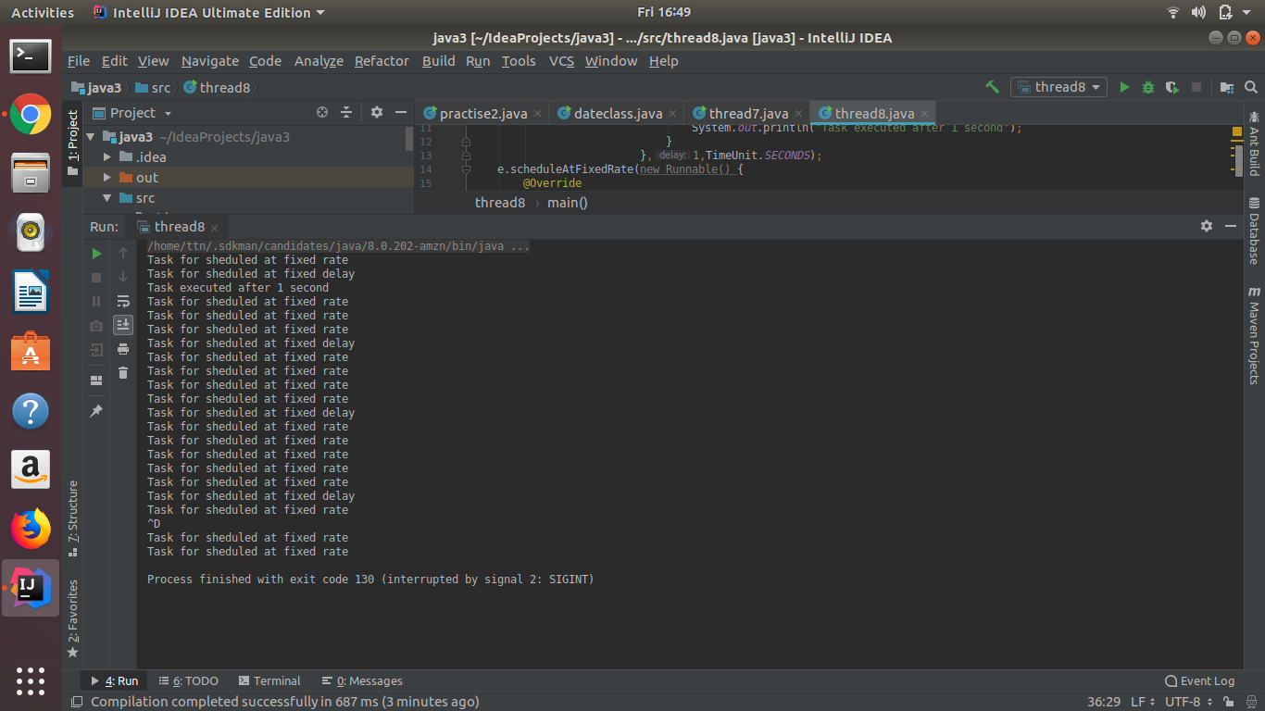

**9.Increase concurrency with Thread pools using newCachedThreadPool() and newFixedThreadPool().**

**newFixedThreadPool() ->**

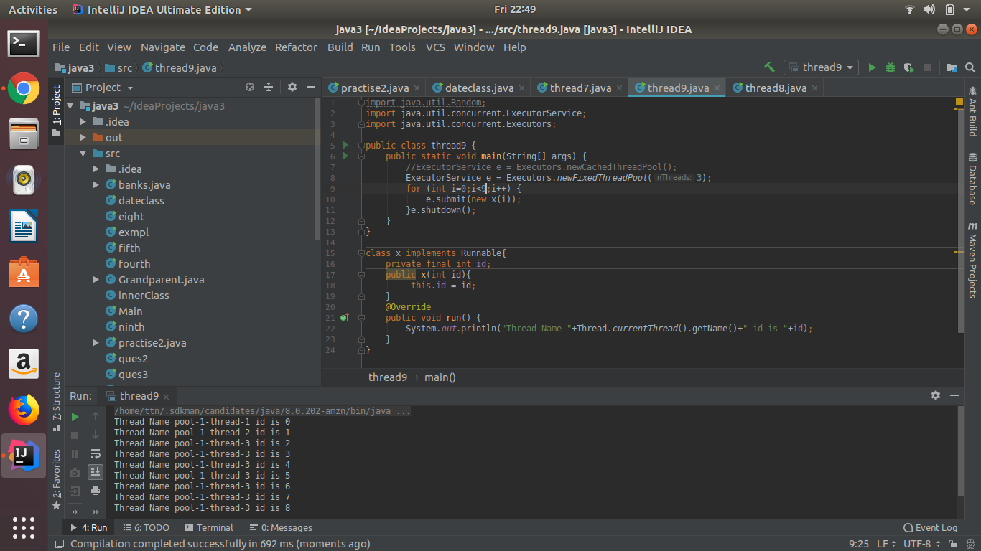

**And newCachedThreadPool() :->**

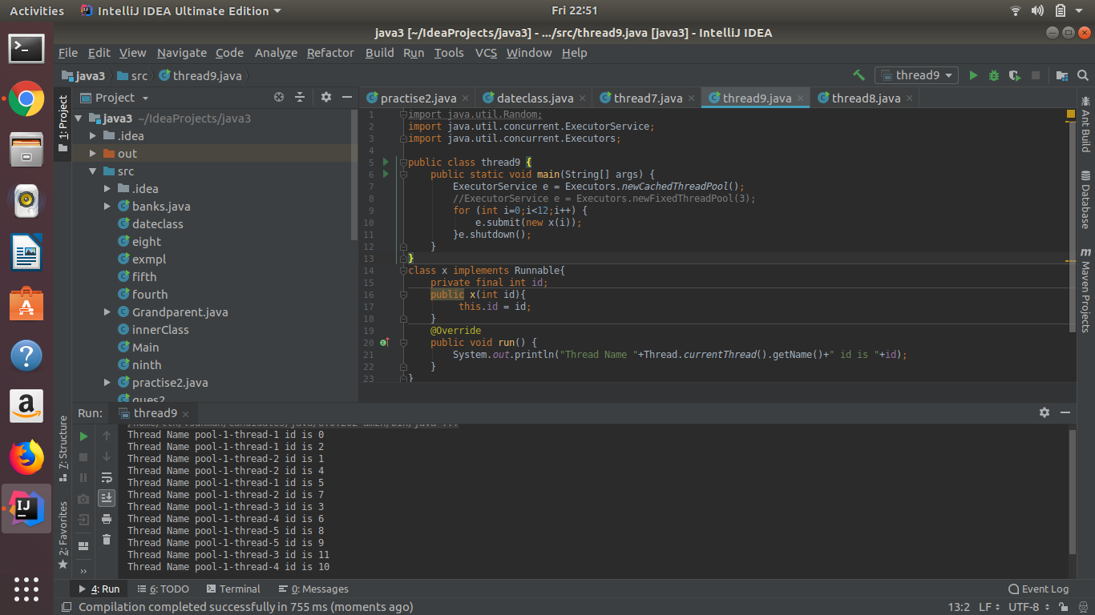

**10.Use Synchronize method to enable synchronization between multiple threads trying to access method at same time.**

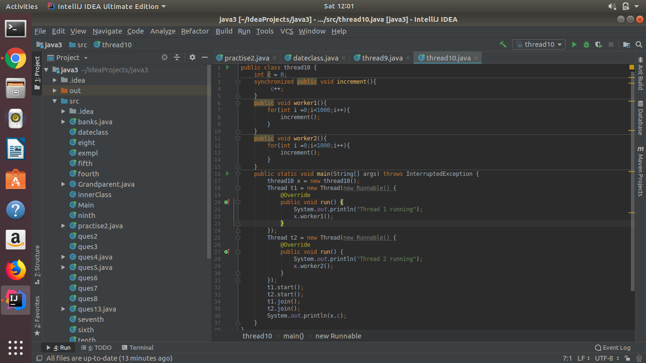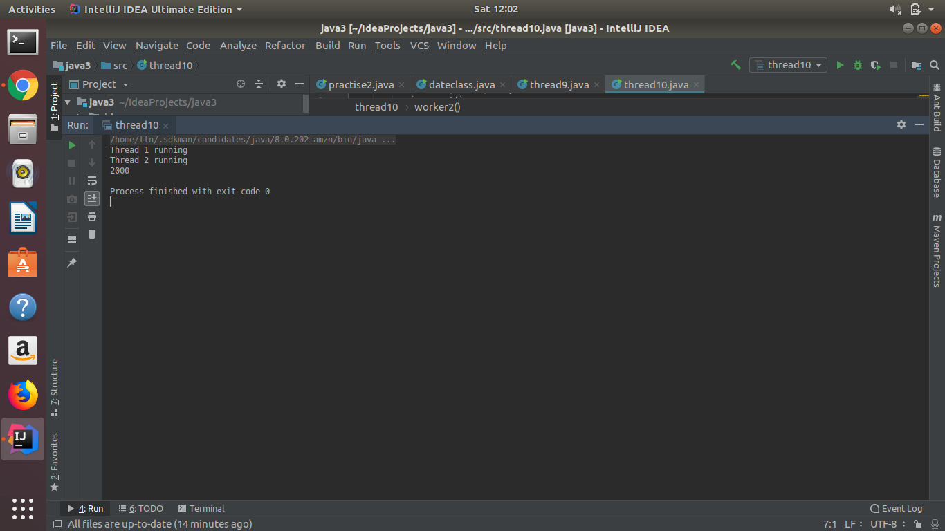

**11.Use Synchronize block to enable synchronization between multiple threads trying to access method at same time.**

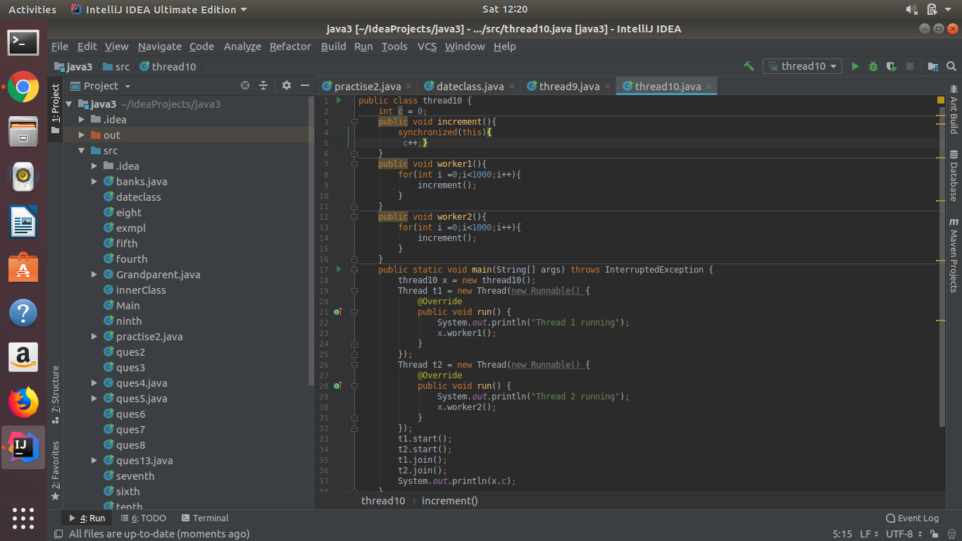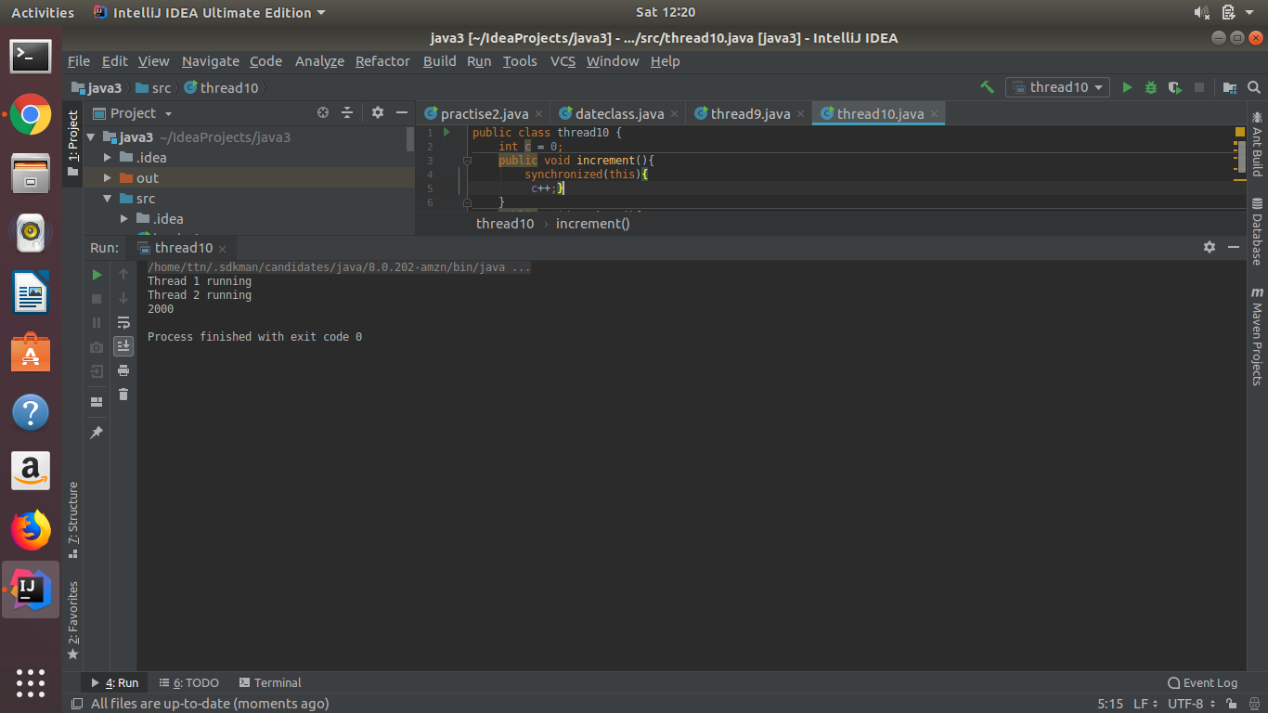

**12.Use Atomic Classes instead of Synchronize method and blocks.**

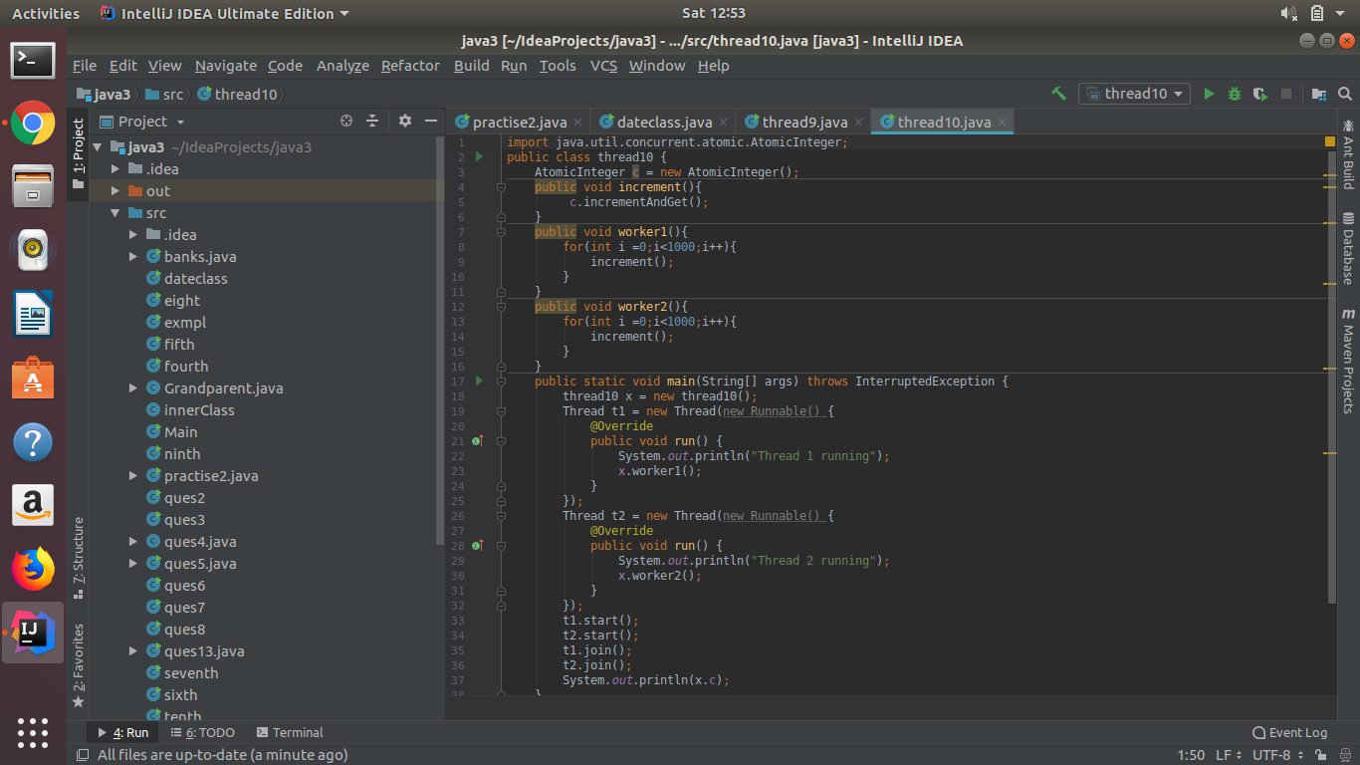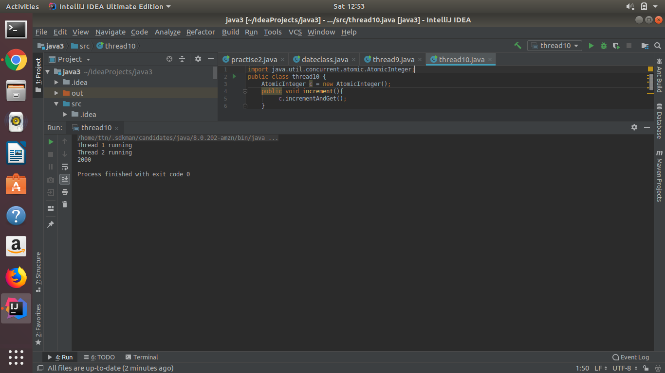

**13.Coordinate 2 threads using wait() and notifyAll().**

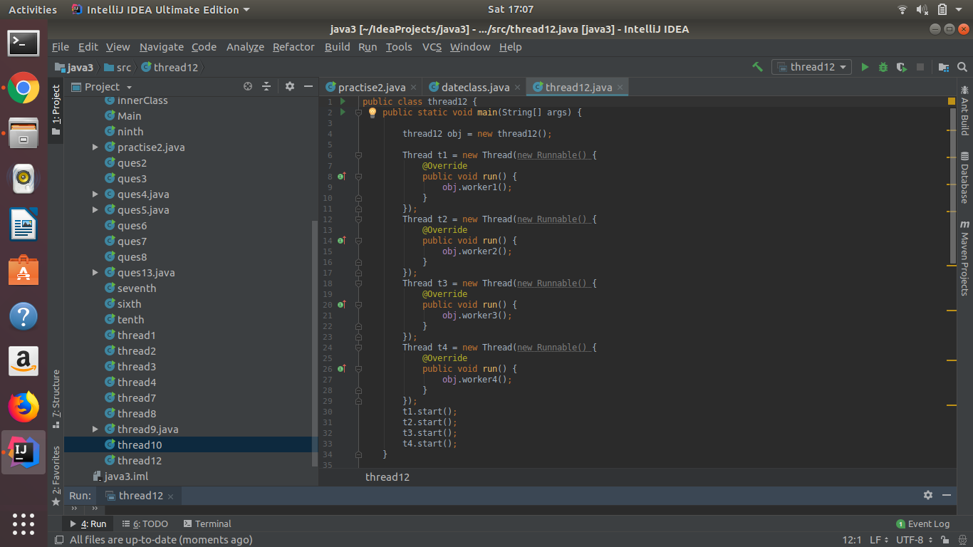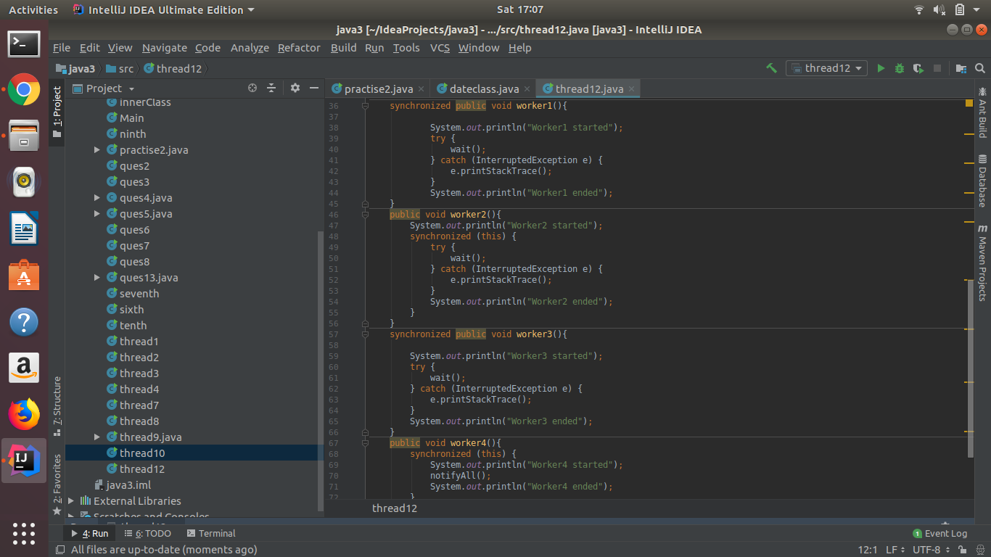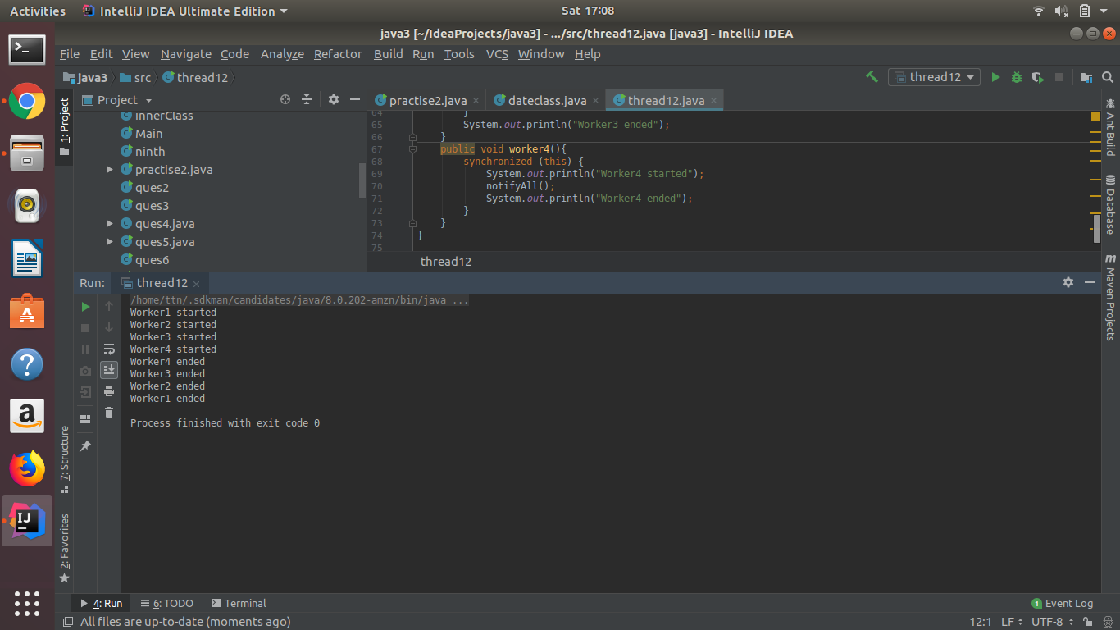

**14.Coordinate mulitple threads using wait() and notify()**



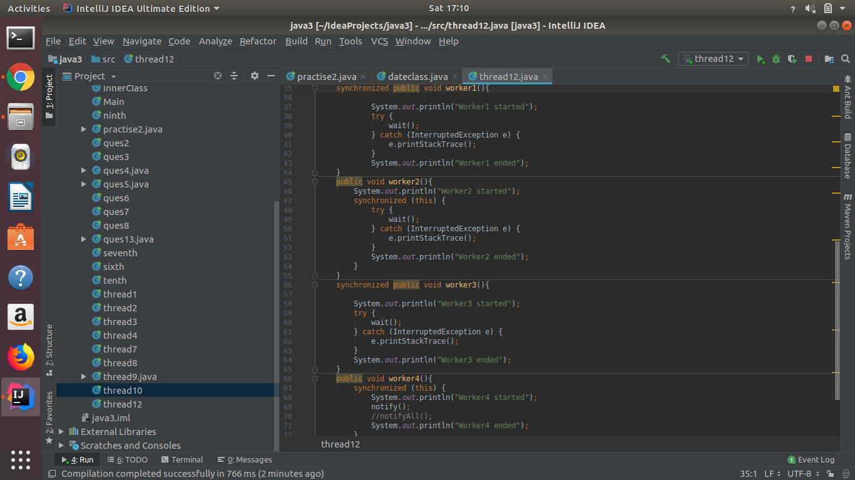

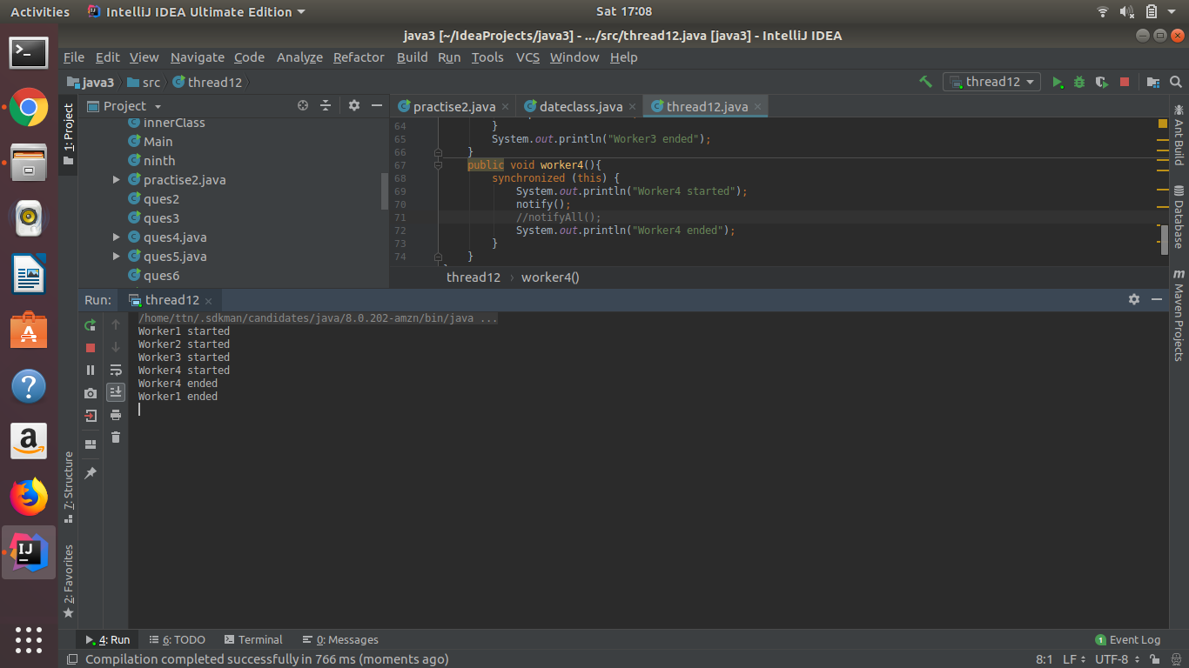

**15.Use Reentract lock for coordinating 2 threads with signal(), signalAll() and wait().**

**signal() and wait()**

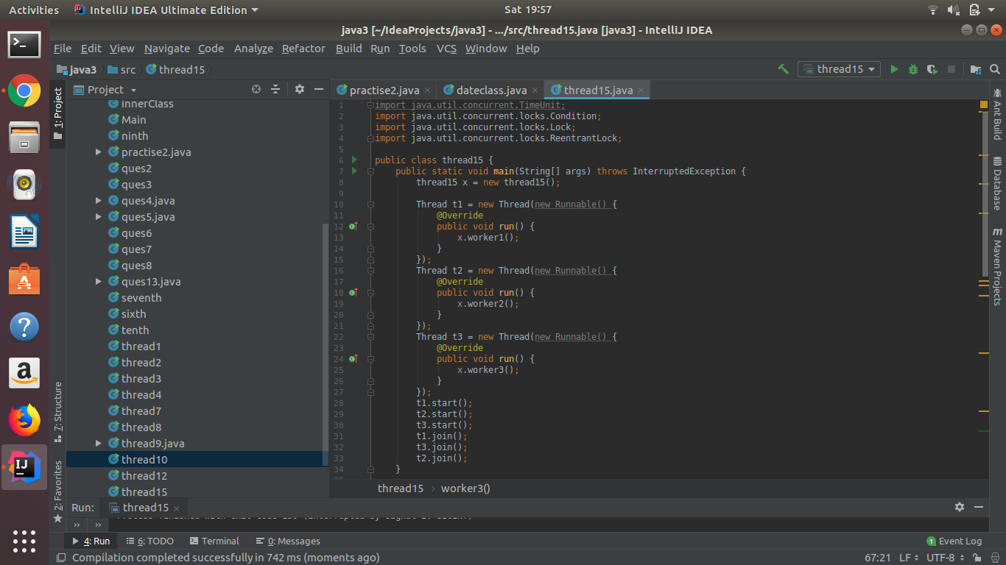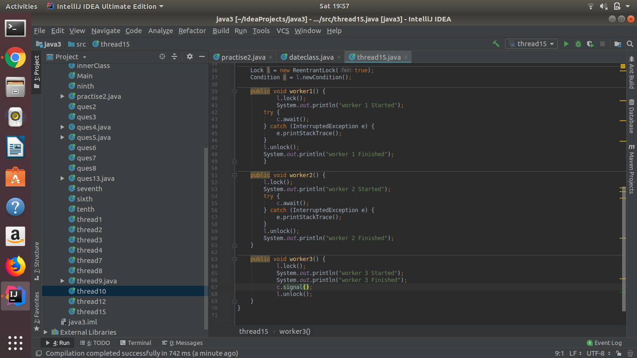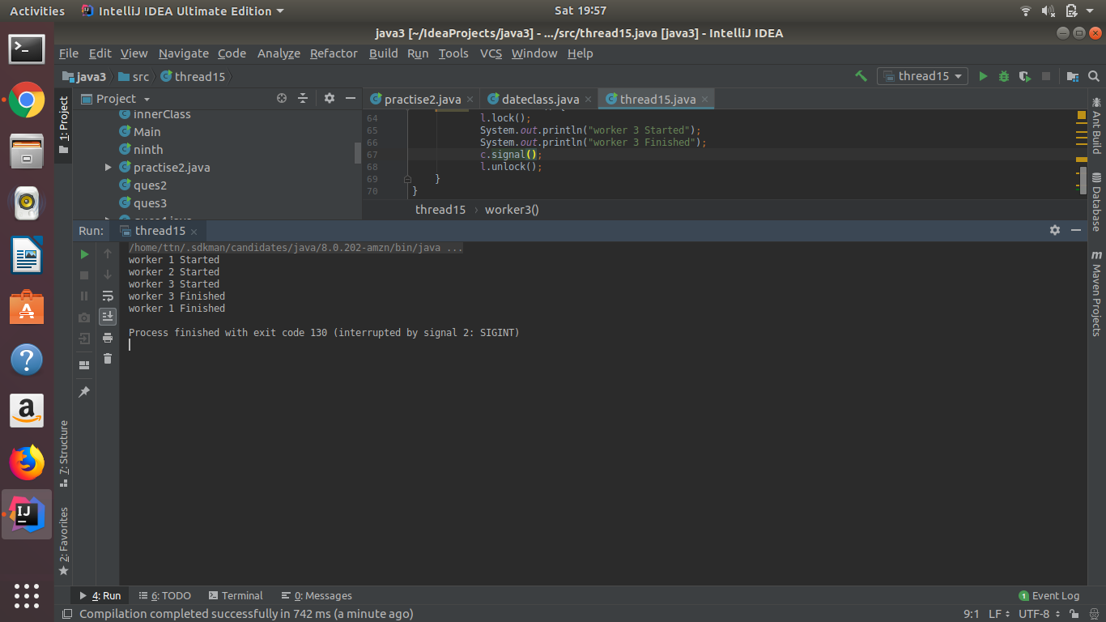

**signalAll() and wait()**

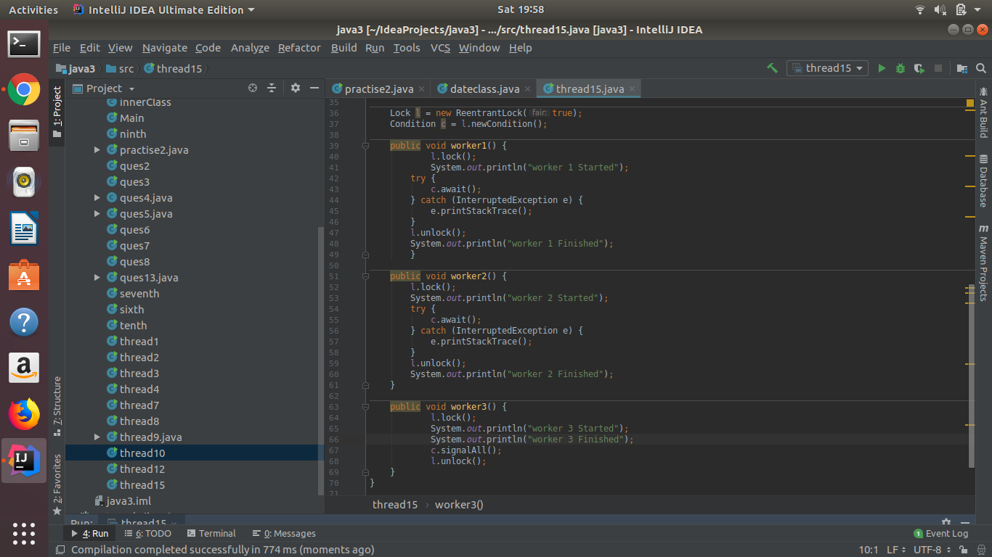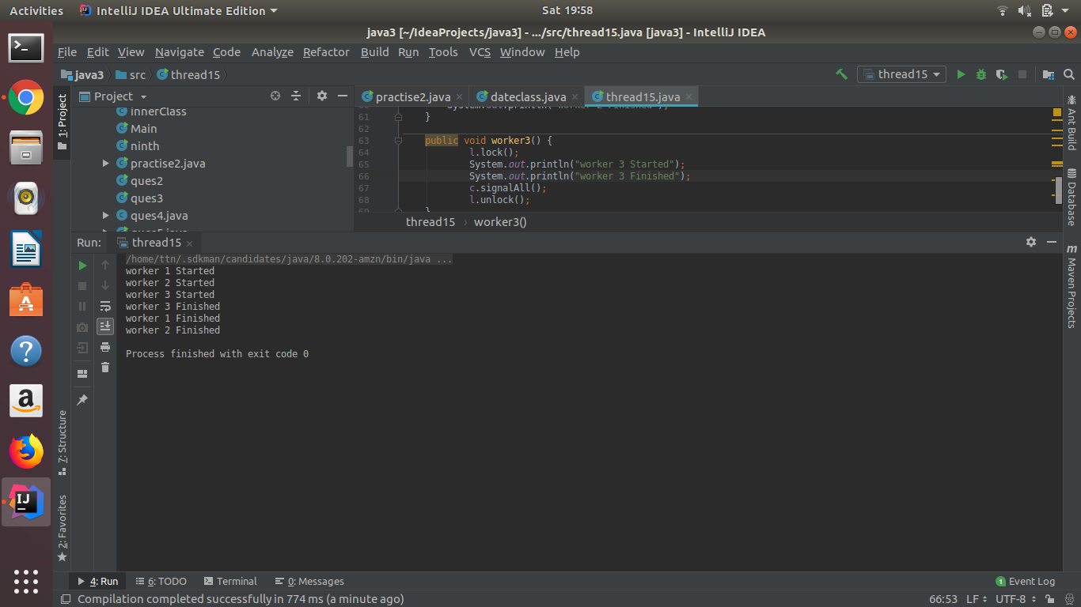

**16.Create a deadlock and Resolve it using tryLock().**

**Deadlock ->**

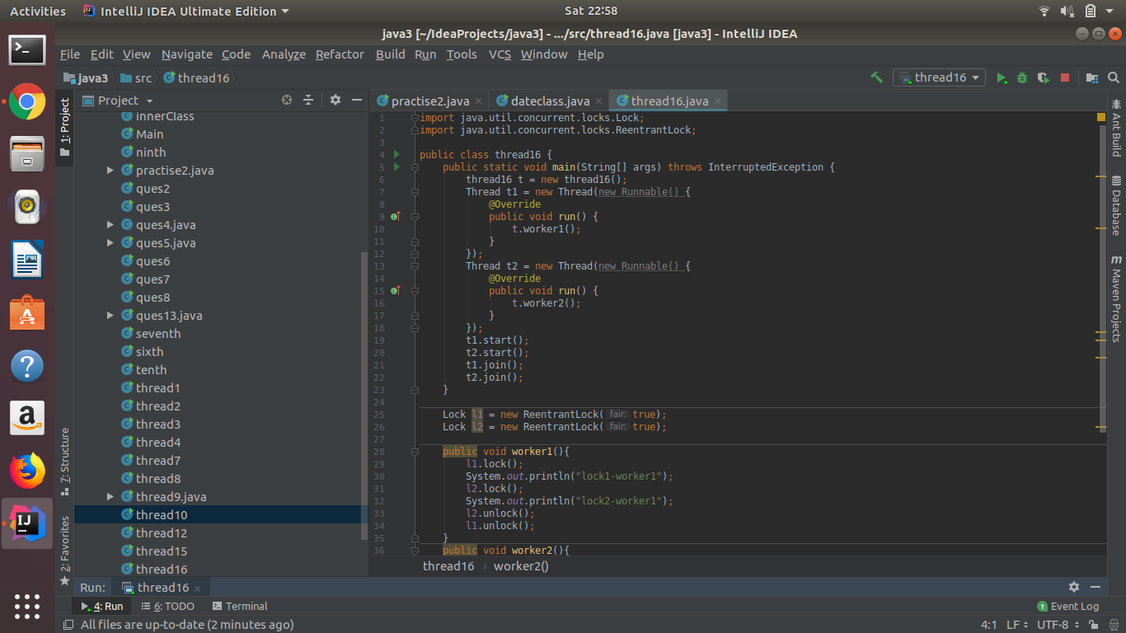

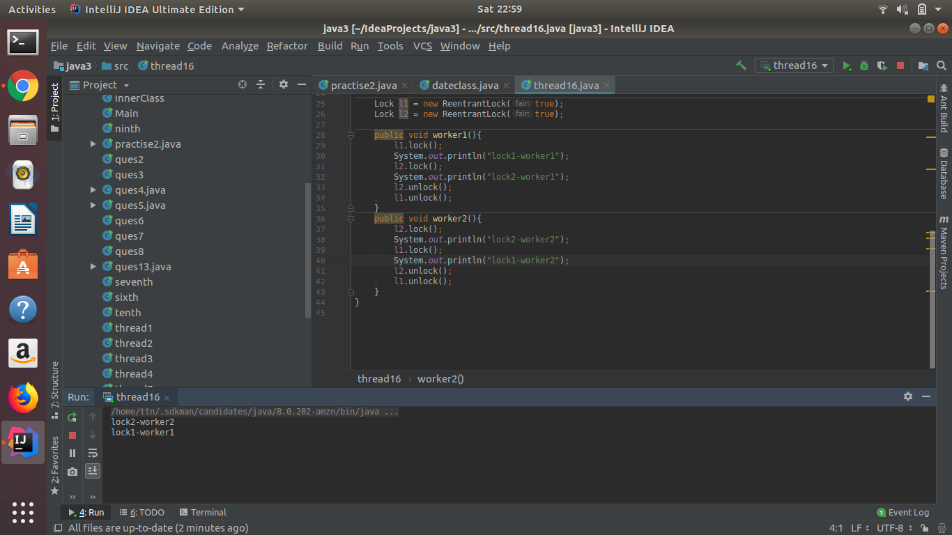

**Solution using tryLock()**

